**Aneesh Pavan Prodduturu**

**Q: How do I create a rubix cube in Houdini SideFX?**

**A:** Firstly, open The Houdini Apprentice.



This interface consists of three panes: the Viewers pane, the Parameters pane, and the Network pane.

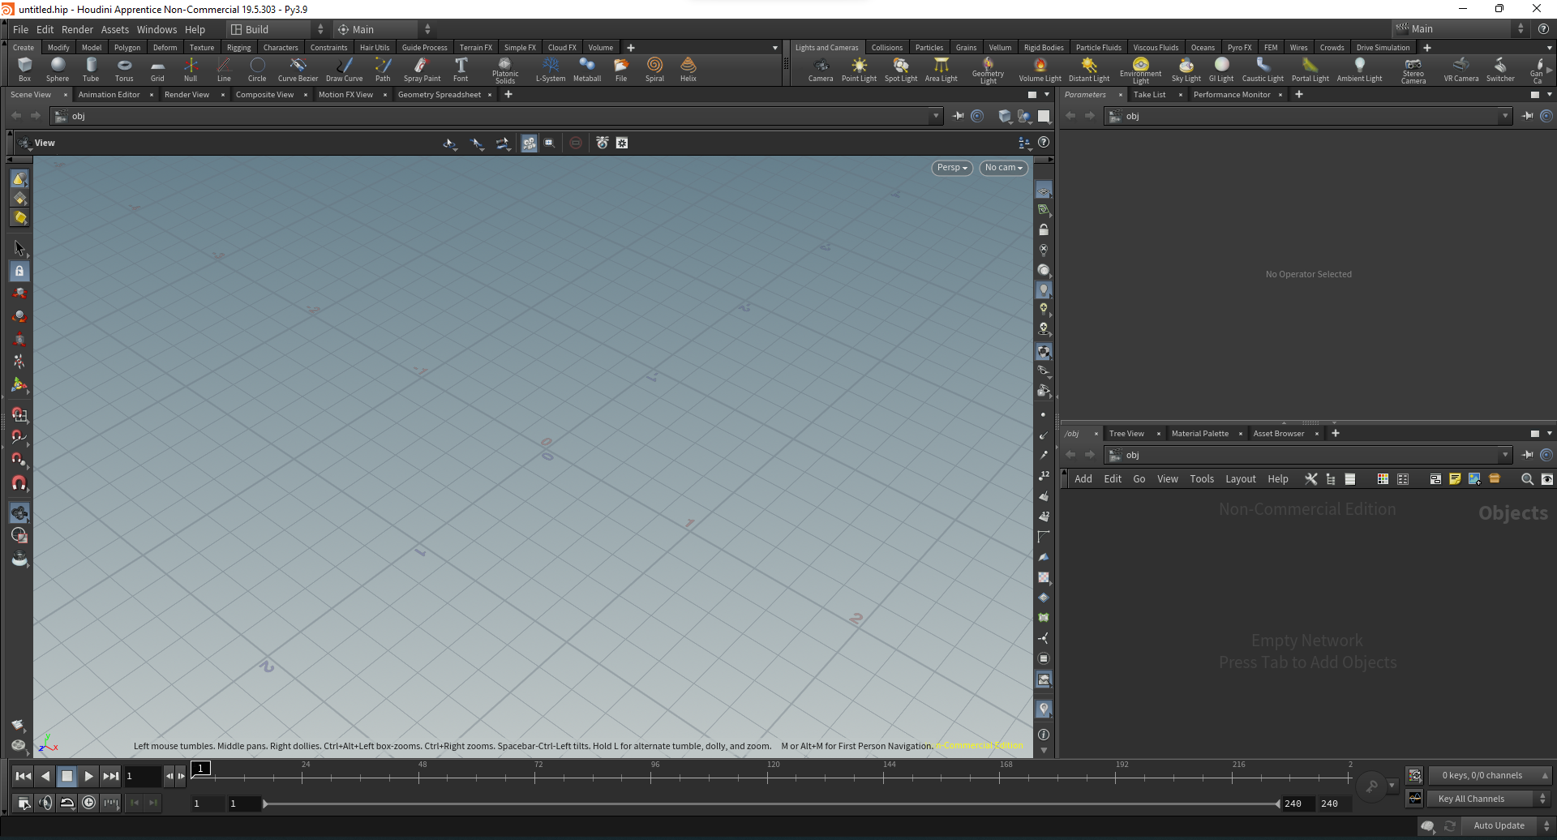

To get started, we first need to change the network pane from objects to geometry by right-clicking, adding geometry in the pane, and double-clicking on the node to turn the pane into geometry.



Moving forward, add a box into the pane and change it’s all axis divisions to 4 and center y element to 0.5.

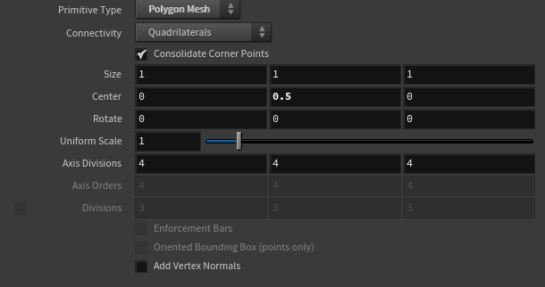

Add polyextrude to bring each element of the cube to be visible clearly or close to a rubix cube. Link box output into polyextrude and divide into **“Individual Elements”** and also increase distance and decrease inset to make it similar to a rubix cube.

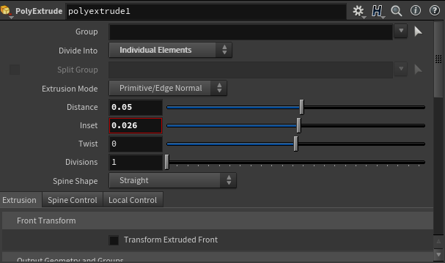

This is how it looks now

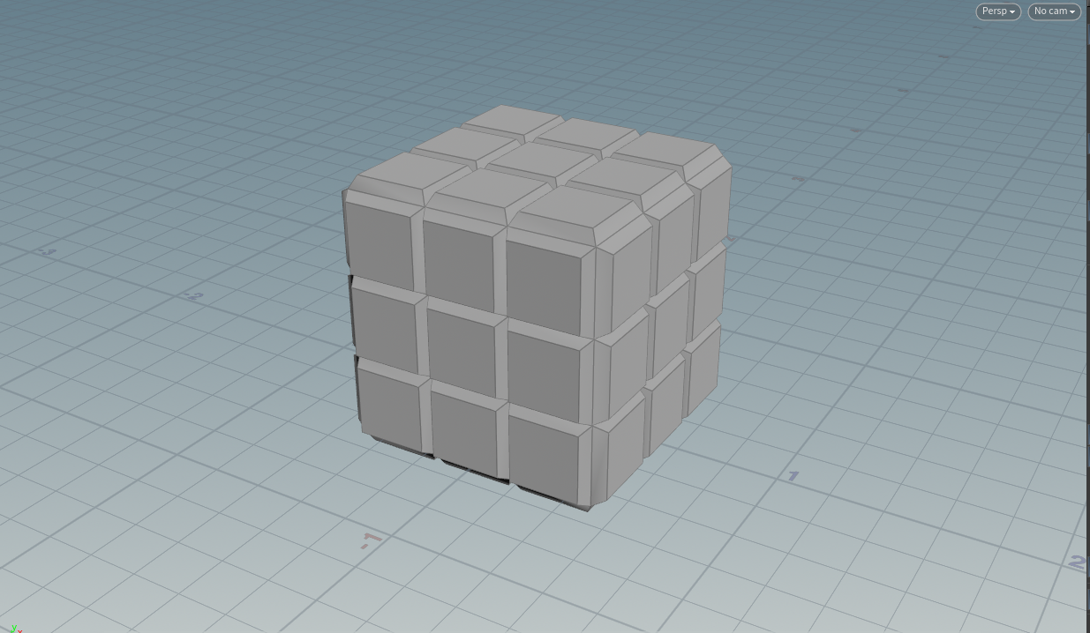

We can further add colors to the cube.

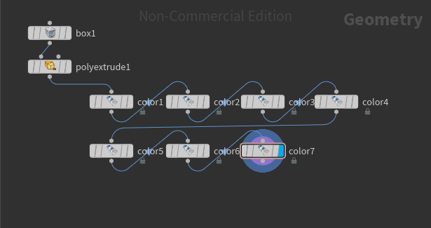

The final rubix cube looks like this

